**CHAPTER 5**

**DC MOTORS**

**&**

**MOTOR DRIVER IC**

**5.1 INTRODUCTION**

A DC motor is any of a class of electrical machines that convert direct current electrical power into mechanical power. The most common types rely on the forces produced by magnetic fields. Nearly all type of DC motors have some internal mechanism, either electromechanical or electronic, to periodically change the direction of current flow in part of the motor. Most type of produce rotator motion. The DC motors fitted with our robot is the reason for movement our robot. Here we use a pair of motors and through the proper control of these motors we can move our robot to different directions include forward, backward, left and right.

For the proper control of our motors we use a motor driver IC.L293D is a typical Motor driver or Motor Driver IC which allows DC motor to drive on either direction. L293D is a 16-pin IC which can control a set of two DC motors simultaneously in any direction. It means that you can control two [DC motor](http://www.rakeshmondal.info/High-Torque-Motor-Low-RPM-Motor) with a single L293D IC.

**5.2 DC MOTORS**

**5.2.1 INTRODUCTION**

An electric motor is an [electric machine](http://en.m.wikipedia.org/wiki/Electric_machine) that converts [electrical energy into mechanical](http://en.m.wikipedia.org/wiki/Electromechanical) energy. In normal motoring mode, most electric motors operate through the interaction between an electric motor's [magnetic field](http://en.m.wikipedia.org/wiki/Magnetic_fields) and [winding currents](http://en.m.wikipedia.org/wiki/Electrical_conductor) to generate force within the motor. In certain applications, such as in the transportation industry with [traction motors](http://en.m.wikipedia.org/wiki/Traction_motor), electric motors can operate in both motoring and [generating or braking](http://en.m.wikipedia.org/wiki/Regenerative_braking) modes to also produce electrical energy from mechanical energy.

Found in applications as diverse as industrial fans, blowers and pumps, machine tools, household appliances, power tools, and disk drives, electric motors can be powered by [direct current (DC)](http://en.m.wikipedia.org/wiki/Direct_current) sources, such as from batteries, motor vehicles or rectifiers, or by [alternating current (AC)](http://en.m.wikipedia.org/wiki/Alternating_current) sources, such as from the power

grid, [inverters](http://en.m.wikipedia.org/wiki/Inverter_(electrical)) or generators. Small motors may be found in electric watches. General-purpose motors with highly standardized dimensions and characteristics provide convenient mechanical power for industrial use. The largest of electric motors are used for ship propulsion, pipeline compression and [pumped-storage](http://en.m.wikipedia.org/wiki/Pumped-storage_hydroelectricity) applications with ratings approaching a megawatt. Electric motors may be classified by electric power source type, internal construction, application, type of motion output, and so on.

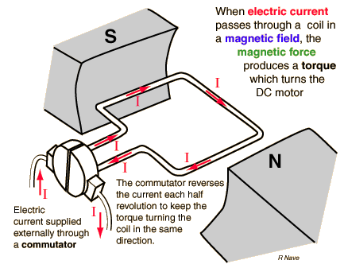

**Figure :** Working of DC Motor

**5.2.2 WORKING OF DC MOTORS**

The direct current (DC) motor is one of the first machines devised to convert electrical power into mechanical power. Permanent magnet (PM) direct current converts electrical energy into mechanical energy through the interaction of two magnetic fields. One field is produced by a permanent magnet assembly; the other field is produced by an electrical current flowing in the motor windings. These two fields result in a torque which tends to rotate the rotor. As the rotor turns, the current in the windings is commutated to produce a continuous torque output. The stationary electromagnetic field of the motor can also be wire-wound like the armature (called a wound-field motor) or can be made up of permanent magnets.

In either style (wound-field or permanent magnet) the commutator acts as half of a mechanical switch and rotates with the armature as it turns. The commutator is composed of conductive segments (called bars), usually made of copper, which represent the termination of individual coils of wire distributed around the armature. The second half of the mechanical switch is completed by the brushes. These brushes typically remain stationary with the motor's housing but ride (or brush) on the rotating commutator. As electrical energy is passed through the brushes and consequently through the armature a torsional force is generated as a reaction between the motor's field and the armature causing the motor's armature to turn. As the armature turns, the brushes switch to adjacent bars on the commutator. This switching action transfers the electrical energy to an adjacent winding on the armature which in turn perpetuates the torsional motion of armature. Permanent magnet (PM) motors are probably the most commonly used DC motors, but there are also some other type of DC motors (types which use coils to make the permanent magnetic field also).

DC motors operate from a direct current power source. Movement of the magnetic field is achieved by switching current between coils within the motor. This action is called "commutation". Many DC motors (brush-type) have built-in commutation, meaning that as the motor rotates, mechanical brushes automatically commutate coils on the rotor. You can use dc-brush motors in a variety of applications. A simple, permanent-magnet dc motor is an essential element in a variety of products, such as toys, servo mechanisms, valve actuators, robots, and automotive electronics.

There are several typical advantages of a PM motor. When compared to AC or wound field DC motors, PM motors are usually physically smaller in overall size and lighter for a given power rating. Furthermore, since the motor's field, created by the permanent magnet, is constant, the relationship between torque and speed is very linear. A PM motor can provide relatively high torque at low speeds and PM field provides some inherent self-braking when power to the motor is shutoff. There are several disadvantages, those being mostly being high current during a stall condition and during instantaneous reversal. Those can damage some motors or be problematic

to control circuitry. Furthermore, some magnet materials can be damaged when subjected to excessive heat and some loose field strength if the motor is disassembled.

When a DC motor is straight to a battery (with no controller), it draws a large surge current when connected up. The surge is caused because the motor, when it is turning, acts as a generator. The generated voltage is directly proportional to the speed of the motor. The current through the motor is controlled by the difference between the battery voltage and the motor's generated voltage (otherwise called back EMF). When the motor is first connected up to the battery (with no motor speed controller) there is no back EMF. So the current is controlled only by the battery voltage, motor resistance (and inductance) and the battery leads. Without any back EMF the motor, before it starts to turn, therefore draws the large surge current. When a motor speed controller is used, it varies the voltage fed to the motor. Initially, at zero speed, the controller will feed no voltage to the motor, so no current flows. As the motor speed controller's output voltage increases, the motor will start to turn. At first the voltage fed to the motor is small, so the current is also small, and as the motor speed controller's voltage rises, so too does the motor's back EMF. The result is that the initial current surge is removed, acceleration is smooth and fully under control.

**Speed Control of DC Motor:**

Motor speed control of DC motor is nothing new. A simplest method to control the rotation speed of a DC motor is to control it's driving voltage. The higher the voltage is, the higher speed the motor tries to reach. In many applications a simple voltage regulation would cause lots of power loss on control circuit, so a pulse width modulation method (PWM)is used in many DC motor controlling applications. In the basic Pulse Width Modulation (PWM) method, the operating power to the motors is turned on and off to modulate the current to the motor. The ratio of "on" time to "off" time is what determines the speed of the motor. When doing PWM controlling, keep in mind that a motor is a low pass device. The reason is that a motor is mainly a large inductor. It is not capable of passing high frequency energy, and hence will not

perform well using high frequencies. Reasonably low frequencies are required, and then PWM techniques will work. Lower frequencies are generally better than higher frequencies, but PWM stops being effective at too low a frequency. The idea that a lower frequency PWM works better simply reflects that the "on" cycle needs to be pretty wide before the motor will draw any current (because of motor inductance). A higher PWM frequency will work fine if you hang a large capacitor across the motor or short the motor out on the "off" cycle (e.g. power/brake PWM) .

**5.3 MOTOR DRIVER IC(L293D)**

**5.3.1 INTRODUCTION**

The L293D motor driver is available for providing User with ease and user friendly interfacing for embedded application. L293D motor driver is mounted on a good quality, single sided non-PTH PCB. The pins of L293D motor driver IC are connected to connectors for easy access to the driver IC’s pin functions. The L293D is a Dual Full Bridge driver that can drive up to 1Amp per bridge with supply voltage up to 24V. It can drive two DC motors, relays, solenoids, etc. The device is TTL compatible. Two H bridges of L293D can be connected in parallel to increase its current capacity to 2 Amp.

**5.3.2 L293D DESCRIPTION**

The L293 and L293D are quadruple high-current half-H drivers. The L293 is designed to provide bidirectional drive currents of up to 1 A at voltages from 4.5 V to 36 V. The L293D is designed to provide bidirectional drive currents of up to 600-mA at voltages from 4.5 V to 36 V. Both devices are designed to drive inductive loads such as relays, solenoids, dc and bipolar stepping motors, as well as other high-current/high-voltage loads in positive-supply applications. All inputs are TTL compatible. Each output is a complete totem-pole drive circuit, with a Darlington transistor sink and a pseudo-Darlington source. Drivers are enabled in pairs, with drivers 1 and 2 enabled by 1,2EN and drivers 3 and 4 enabled by 3,4 EN, When an enable input is high, the associated drivers are enabled and their outputs are active and in phase with their inputs. When the enable input is low, those drivers are

disabled and their outputs are off and in the high-impedance state. With the proper data inputs, each pair of drivers forms a full-H (or bridge) reversible drive suitable for solenoid or motor applications. On the L293, external high-speed output clamp diodes should be used for inductive transient suppression. A VCC1 terminal, separate from VCC2, is provided for the logic inputs to minimize device power dissipation. The L293and L293D are characterized for operation from 0°C to 70°C.

L293D is a typical Motor driver or Motor Driver IC which allows DC motor to drive on either direction. L293D is a 16-pin IC which can control a set of two DC motors simultaneously in any direction. It means that you can control two [DC motor](http://www.rakeshmondal.info/High-Torque-Motor-Low-RPM-Motor) with a single L293D IC. Dual H-bridge Motor Driver integrated circuit (IC).The l293d can drive small and quiet big [motors](http://www.rakeshmondal.info/High-Torque-Motor-Low-RPM-Motor) as well, check the Voltage Specification at the end of this page for more info.

**5.3.3 CONCEPT**

It works on the concept of H-bridge. H-bridge is a circuit which allows the voltage to be flown in either direction. As you know voltage need to change its direction for being able to rotate the motor in clockwise or anticlockwise direction, Hence H-bridge IC are ideal for driving a DC motor.

In a single l293d chip there two h-Bridge circuit inside the IC which can rotate two dc motor independently. Due its size it is very much used in robotic application for controlling DC motors. Given below is the pin diagram of a L293D motor controller. There are two Enable pins on l293d. Pin 1 and pin 9, for being able to drive the motor, the pin 1 and 9 need to be high. For driving the motor with left H-bridge you need to enable pin 1 to high. And for right H-Bridge you need to make the pin 9 to high. If anyone of the either pin1 or pin9 goes low then the motor in the corresponding section will suspend working. It’s like a switch.

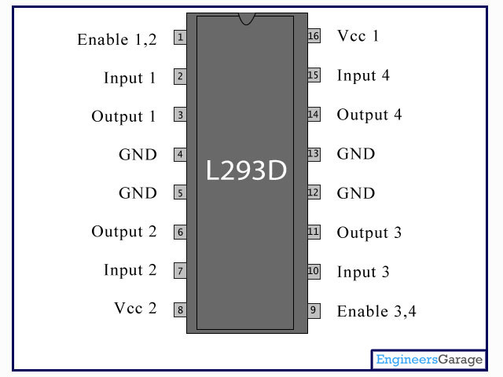

**Figure :** L293D Pin Diagram

**5.3.4 WORKING OF L293D**

There are 4 input pins for this l293d, pin 2,7 on the left and pin 15 ,10 on the right as shown on the pin diagram. Left input pins will regulate the rotation of motor connected across left side and right input for motor on the right hand side. The motors are rotated on the basis of the inputs provided across the input pins as LOGIC 0 or LOGIC 1.In simple you need to provide Logic 0 or 1 across the input pins for rotating the motor.

**L293D Logic Table.**

Lets consider a Motor connected on left side output pins (pin 3,6). For rotating the motor in clockwise direction the input pins has to be provided with Logic 1 and Logic 0.

• **Pin 2** = **Logic 1** and **Pin 7** = **Logic 0** | Clockwise Direction  
• **Pin 2** = **Logic 0** and **Pin 7** = **Logic 1** | Anticlockwise Direction  
• **Pin 2** = **Logic 0** and **Pin 7** = **Logic 0**| Idle [No rotation] [Hi-Impedance]  
• **Pin 2** = **Logic 1** and **Pin 7** = **Logic 1** | Idle [No rotation]

In a very similar way the motor can also operated across input pin 15,10 for motor on the right hand side.



**Figure:** Circuit Diagram For L293D motor driver IC controller:

**5.3.5 VOLTAGE SPECIFICATION**

VCC is the voltage that it needs for its own internal operation 5v; L293D will not use this voltage for driving the motor. For driving the [motors](http://www.rakeshmondal.info/High-Torque-Motor-Low-RPM-Motor) it has a separate provision to provide motor supply VSS (V supply).  L293d will use this to drive the motor. It means if you want to operate a motor at 9V then you need to provide a Supply of 9V across VSS Motor supply.

The maximum voltage for VSS motor supply is 36V. It can supply a max current of 600mA per channel. Since it can drive motors Up to 36v hence you can drive pretty big motors with this l293d.

VCC pin 16 is the voltage for its own internal Operation. The maximum voltage ranges from 5v and up to 36v.Don’t Exceed the Vmax Voltage of 36 volts or it will cause damage.

**5.3.6 FEATURES**

* Featuring Unitrode L293 and L293D Products Now From Texas Instruments
* Wide Supply-Voltage Range: 4.5 V to 36 V
* Separate Input-Logic Supply
* Thermal Shutdown
* High-Noise-Immunity Inputs
* Internal ESD Protection
* Functional Replacements for SGS L293 and SGS L293D
* Output Current 1 A Per Channel(600 mA for L293D)
* Peak Output Current 2 A Per Channel (1.2 A for L293D)
* Output Clamp Diodes for Inductive Transient Suppression (L293D)

**H BRIDGE CIRCUIT**

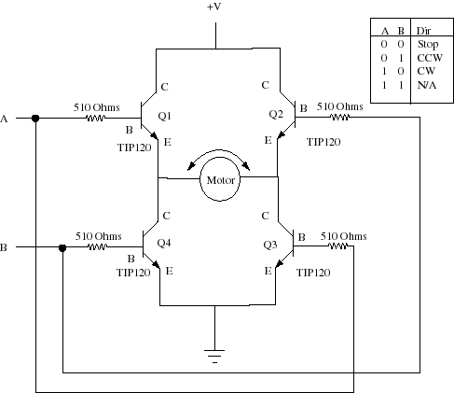

**5.4 CONCLUSION**

A DC motors can operate in both motoring and [generating or braking](http://en.m.wikipedia.org/wiki/Regenerative_braking) modes to also produce electrical energy from mechanical energy. Most DC motors operate through the interaction between an electric motor's [magnetic field](http://en.m.wikipedia.org/wiki/Magnetic_fields) and [winding currents](http://en.m.wikipedia.org/wiki/Electrical_conductor) to generate force within the motor.

The L293D is a popular motor driver IC that is usable from 6 to12V, at up to 1A total output current. By itself, the IC is somewhat difficult to wire and use, but the Compact L293D Motor Driver makes it much more convenient to use.